Get Up to $2000 ($200 for individuals) for Using Biodiesel in Your Diesel Equipment
Fleets and individuals using diesel-powered trucks can now earn rebates for using biodiesel blends above 10%. The rules are simple:
For Fleets
Fleets using diesel–powered trucks and equipment can receive $1/gallon rebate for up to 2000 gallons of biodiesel per year.
- Purchase bulk fuel or retail
  - Private fueling (as a drop-in fuel or delivery of blended fuel).
  - Retail fueling (via fuel card or driver receipts).
- Certify your company purchase by filling out this form
- Turn in your completed rebate form and receipt(s) one at a time or all at once.
Fleets Send Receipts and Rebate Request to:
Attn: Biodiesel Rebate
Central Kansas Clean Cities Coalition
220 W Broadway
Wichita, KS
Or send an email to shawn@metroenergy.org with Biodiesel Rebate in the subject line.
For Individuals
Individuals using diesel-powered trucks can now earn up to $200 in rebates for using biodiesel blends above 5%. The rules are simple:
- Buy biodiesel and keep your receipt
- Certify your purchase by filling out this form
- Send your completed form with your original receipt to the address below
- Receive $1/gallon of biodiesel, up to $200 per year
You can keep your receipts and turn them all in at once, or turn them in one or two at a time. Minimum purchase of 20 gallons per reimbursement (may be two or more separate transactions with fuel retailer). Each household can earn a maximum of $200 per year.
Individuals Send Receipts and Rebate Request to:
Attn: Biodiesel Rebate
Kansas Soybean Commission
1000 SW Red Oaks Place
Topeka, KS 66615
Or send an email to hall@kansassoybeans.org with Biodiesel Rebate in the subject line.


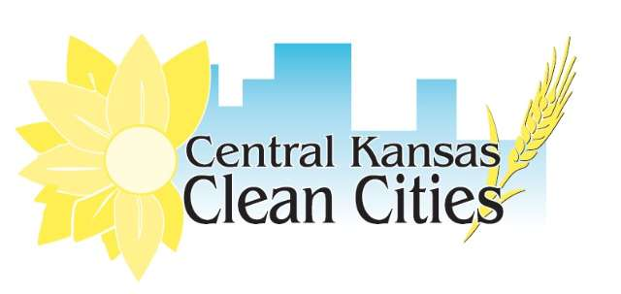
Rebate and financial support provided by Kansas Soybean Commission, with support from Metropolitan Energy Center’s Clean Cities Coalitions.
Metropolitan Energy Center is a 501(c)(3) nonprofit that works to improve our environment through energy education, training and consulting, alternative fuels, outreach programs and workforce development. Visit www.metroenergy.org for more about your Clean Cities Coalition.

