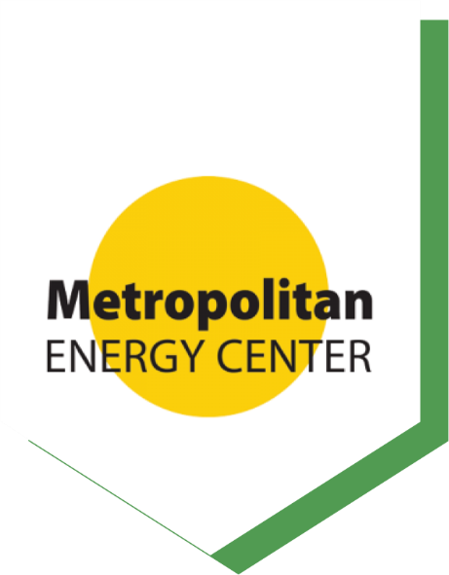


Metropolitan Energy Center November 2024

Brief: Building Energy Codes and Standards
  - In Kansas and Missouri

Brief: Building Energy Codes and Standards
  - In Kansas and Missouri

Executive Summary
Metropolitan Energy Center’s (MEC) report on the International Energy Conservation Code (IECC) highlights the code’s potential to advance energy efficiency, public health and economic growth in the Kansas City region. Adoption of the IECC can enhance building performance, reduce utility costs and create cleaner, healthier communities.


Key Benefits
An updated and enforced energy code:

Creates healthier and more comfortable buildings

Protects residents from extreme weather

Promotes energy equity

Boosts economic development
Energy Efficiency: Adopting an unamended iteration of the 2021 or 2024 IECC as policy is projected to reduce energy use and greenhouse gas emissions. Economic analysis indicates that every dollar spent on energy code compliance and enforcement yields $6 in energy savings, according to the U.S. Department of Energy.
Public Health: MEC’s study with Children’s Mercy Hospital and University of Missouri – Kansas City shows a 34% drop in asthma cases in homes with energy upgrades.
Economic Growth: As the energy code and standards are updated and adopted, new employment opportunities become available. Clean energy companies employed almost 24,000 Kansans and 54,000 Missourians in 2021, a 5% increase from 2020, according to Clean Jobs Midwest.
Energy Equity: The 2021 IECC helps address energy inequities by improving housing quality in historically underserved areas, allowing residents to save on utility costs while enjoying more comfortable living conditions.
Community Engagement: Through webinars and workshops, MEC educates stakeholders on the value of the IECC, strengthening regional support for energy efficiency and sustainable building practices.

Challenges and Lessons Learned
Home-Rule Complexity: Kansas and Missouri’s “home-rule” policies mean each jurisdiction can decide on code adoption, creating inconsistencies across the region.
Resource Limitations: Smaller municipalities struggle with limited budgets, affecting their ability to train staff and enforce energy codes.
Public Perception: Misunderstandings about initial costs vs. long-term savings hinder adoption. Clear communication on cost-benefits is needed.
Energy Equity Gaps: Historic inequities in housing make it harder for underserved communities to access energy upgrades.

Recommendations
Expand Code Adoption: Encourage uniform adoption of the IECC across jurisdictions to streamline enforcement and promote consistent efficiency.
Increase Training: Provide ongoing, accessible training to support code compliance, focusing on workforce diversity and inclusion in clean energy roles.
Target Energy Equity: Address housing inequities with energy programs focused on low-income areas to reduce utility costs and improve public health.
Boost Public Awareness: Continue advocacy and educational outreach to highlight the benefits of energy codes.

Leverage Federal Funding: Use federal grants to support code adoption, clean energy projects and job creation in disadvantaged communities.
Support Benchmarking and Performance Standards: Implement building energy benchmarking and performance standards to monitor and measure energy use and ensure ongoing improvements in efficiency.

Conclusion
The report advocates for widespread IECC adoption in the Kansas City region as a critical step toward an economically vibrant and equitable energy future. The code’s adoption can catalyze growth in clean energy jobs and improve public health and economic stability. MEC’s role in providing training and resources will be crucial in navigating adoption challenges, fostering a collaborative approach across the Kansas City region.

